1. Write  a function to Calculate the total stock value for a given category:

(Stock value=ROUND(SUM(unit_price * units_in_stock)::DECIMAL, 2)

Return data type is DECIMAL(10,2)

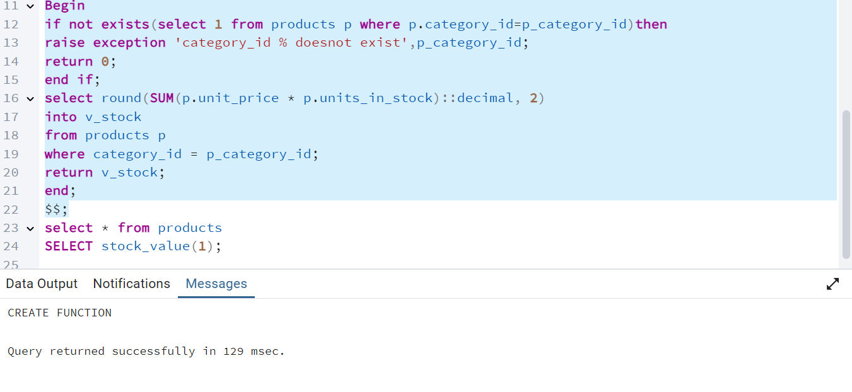

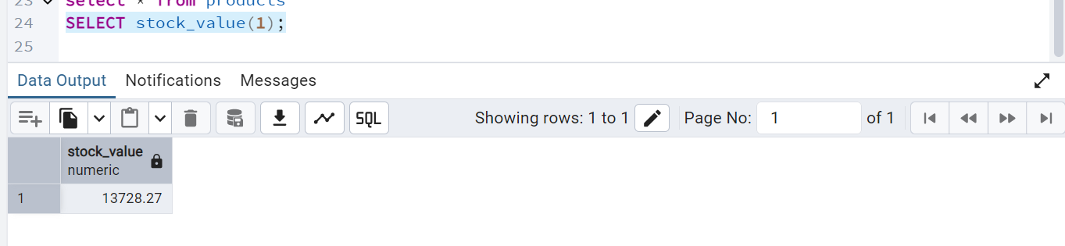

2. Try writing a   cursor query which I executed in the training.

create or replace procedure update_low_stock_product_prices()

language plpgsql

as $$

declare

product_record RECORD;

product_cursor cursor for

select product_id, product_name, unit_price, units_in_stock

from products;

begin

open product_cursor;

loop

fetch product_cursor into product_record;

exit when not found;

-- Check condition

if product_record.units_in_stock < 10 then

update products

set unit_price = unit_price * 1.10

where product_id = product_record.product_id;

raise notice 'Updated product % - new price: %',

product_record.product_name,

(product_record.unit_price * 1.10);

end if;

end loop;

close product_cursor;

end;

$$;

